LEARNING ENGLISH:
THE FIRST STEPS
by
Michael Stuart Rose



Part | Topic(s)
One | Introductions, Pronouns, Verbs “to be”, “to have”
Two | Professions
Three | More Pronouns
Four | Negatives and Questions, Verb “to do”
Five | The present tense, Verb “to give”
Six | More Negatives and Questions, Verb “to like”
Seven | Contractions
Eight | Families and Relatives
Nine | Nationalities
Ten | Professions
Eleven | Verbs - Present Simple and Continuous
Twelve | Pronouns (complete)
Learning English – The First Steps

Part Ten: Professions

What do you do? I'm a/an _____________________.

What does he do? He's a/an ____________________.

What does she do? She's a/an ____________________.

Exercise 10. Name the professions.

 |  | 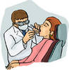 | 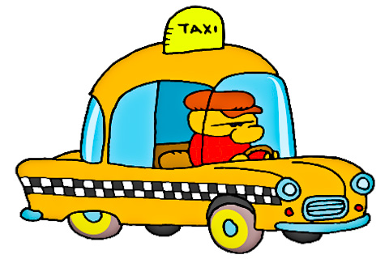
1. ________ | 2. ________ | 3. ________ | 4. ________
 |  |  | 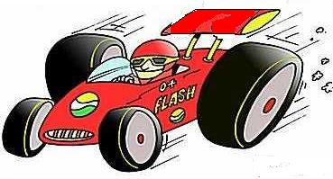
5. ________ | 6. ________ | 7. ________ | 8. ________
 |  | 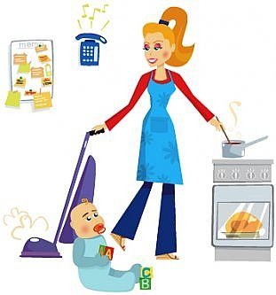 | 
9. ________ | 10. ________ | 11. ________ | 12. ________

